Executing the initial pipeline which automatically triggers other pipelines one by one

Step 1: - Create a lambda function that will detect the execution and success of the initial pipeline and run other pipelines one by one

I have 3 pipelines initial pipeline is named 1 and the other 2 and 3

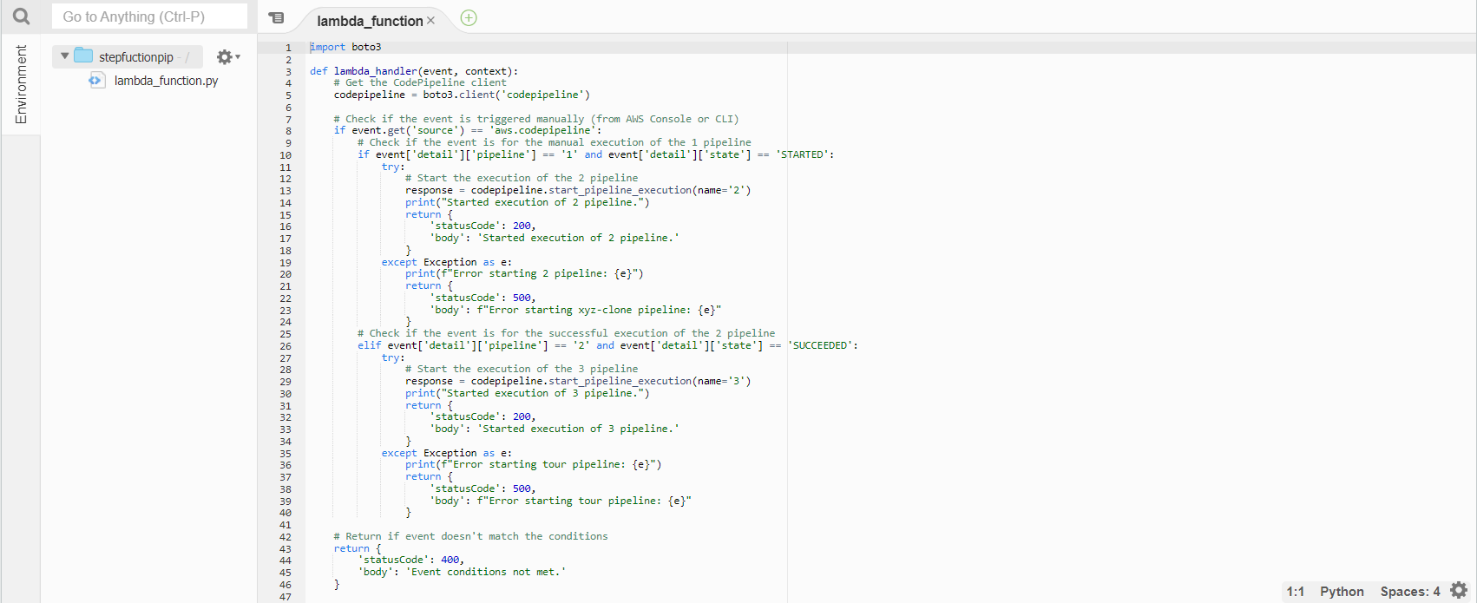

Step 2: - Create 2 event rules in the event bridge

In 1st event rule, we will add an event pattern for the start of pipeline 1

In 2nd, we will add the event pattern of the success of 2nd pipeline

1st

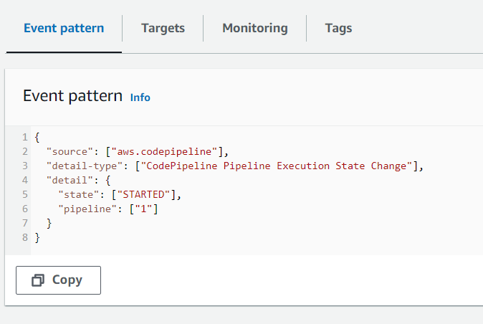

2nd

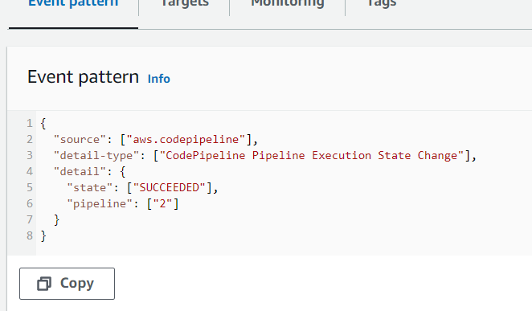

Pipelines

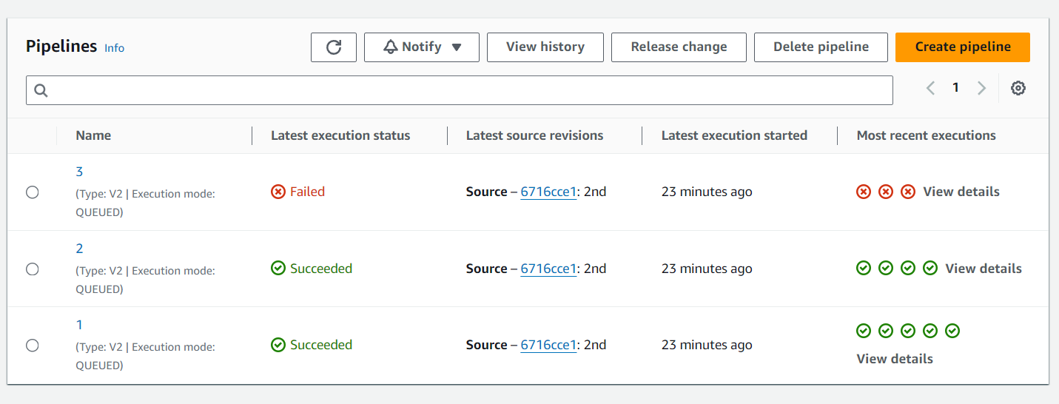

For testing purposes, I have created 3rd pipeline which fails

* I have tested a case in which I have kept pipeline 3 (pipeline which fails) in second place so that I can check whether pipeline 2 runs even if pipeline 3 fails
* As a result, it will not run pipelines further if the pipeline fails